Protein structure information using PyMol

I recommend Pymol for viewing macromolecular structures: Download https://www.pymol.org/
Excellent extensive guide and Manual http://www.pitt.edu/~epolinko/IntroPyMOL.pdf]
When the programme is opened go to File and open a protein structure that you have downloaded from the Protein Data Bank. These will have a *.pdb extension.

To download Protein Data Bank (pdb) datafiles
Main site for pdbank: http://www.wwpdb.org/
Best PDB site for getting and downloading pdb datafiles. http://www.rcsb.org/pdb/home/home.do
Find your structure: In the search window type in name of enzyme, or pdb number and an author of the paper etc.
Clk on title of the protein. This goes to a much more extensive description (valuable). Rt Clk on Download Files and choose the option of saving as pdb file.

Instructions for using Pymol.

The programme includes the Viewer plus a control panel. Both come up together. To increase size of the viewer, drag from its corner. OPEN new structure (*.pdb) in File.
SAVE your session: In File Clk Save session & name it. It is worth doing this at start then you can just update the save session frequently (each subsequent time Save As with new name). Repeat this with different names as you progress. This is necessary in case a mistake is made so you can go back (I have found no way of going back through your process or undoing a command). (Note - File / re-initialize: starts with the same molecule so no need to quit pymol and start again.)

There are three menus:
TOP (control panel). This has File, Display etc. Use Display for changing background etc (I use black, but white for printing or publication). If your computer is fast then click Maximum Quality. This refers to the image on screen – not to the final product. Below the control panel is the typing bar for Select etc.
Use Settings: Cartoons, transparency, rendering. Use these to change selected parts or the whole. For example loops can be made slight transparent etc. Helices can be made thicker etc.

RHS top menu (TR) with drop down menus. On the left of it choose whether you want to act on the whole molecule or on what you have selected (sele)
A is Action – eg Centre, align, remove atoms
S is Show – show molecule or selected parts as spheres, ribbons, lines etc
H is Hide – hide waters, dots, sticks, side chains etc.
L is Label – label residues, elements, chains etc.
C is Colour – by elements, chains, etc. Huge range so explore.
RHS bottom menu (BR) – Info on mouse actions; And Selections – scroll through these to select atom, molecule etc. After selecting molecule (for example) you can Clk on any molecule on the screen and act on it (TR).

Put sequence of protein across top (Clk Display/ Sequence or Clk S in RBmenu). This can then be used to select parts of sequence or individual amino acids. The amino acid sequence is followed by haem pqq etc and then waters which are shown as red crosses and can be removed. NB Can have 2 sequences present; then can select a helix sequence and display as Cartoon and on the select individual amino acids and show.
NB if the protein is a dimer then 2 complete sequences are shown one after the other. Can remove one whole set to work on a single dimer. Select /molecule (BR) then in TR menu Action/remove.

Mouse actions: These are shown in BR menu
Rotate: Lt Clk on structure and move mouse (imagine structure as a ball).
To change centre of rotation: BR menu/Select atom or residue Clk on residue then choose Centre in Action panel
Rotate in plane of screen: L clk outside structure and move cursor.
Move structure; Clk wheel and move cursor.
Zoom; Rt clk
Slabbing; Rotate wheel
Note. Selected atoms are marked on screen with dots which disappear when an area outside the structure is clicked.

Figure 1. Shows 3 molecules of cytochrome c_{H} as lines with waters shown. The 3 menus are Top with File etc; Top Right (TR) on the black part on right of molecule; Bottom Right (BR) is below that.

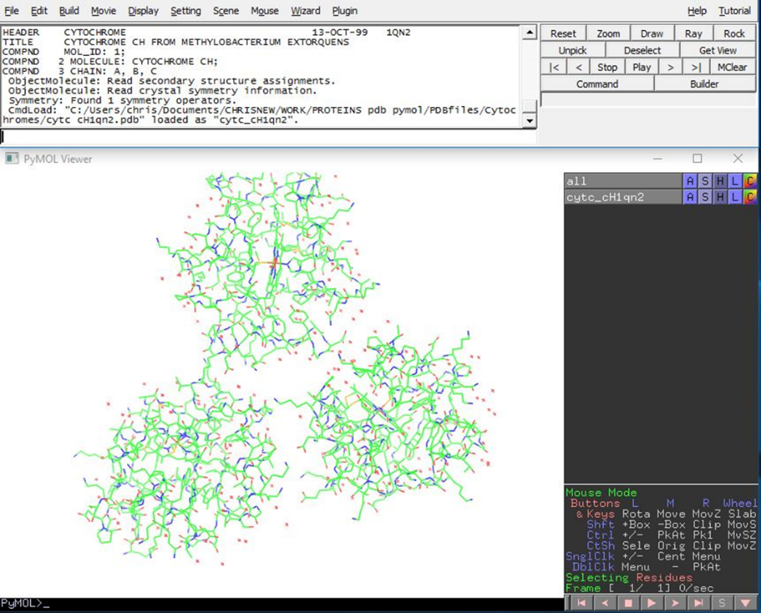

Example: cytochrome C_{H} http://www.rcsb.org/pdb/explore/explore.do?structureId=1QN2

The structure is always presented as Lines. Even if these are replaced with ribbons etc it is a good idea to leave them until your structure is well developed. They can then be hidden (and brought back later if necessary).
The cytochrome displays 3 copies (it had crystallised as a trimer). See Figure 1 (above)
To remove two of them: BR menu Select/molecule; Clk on two unwanted structures;
TR menu (sele) Action / remove atoms.
Remove waters: TR menu Action/remove waters. If you think you might want them later then Hide/waters.
Show sequence: BR / S. Note that the haem molecule is represented by HEC at the end of the sequence.
So we now have one cytochrome molecule represented as sticks.
Colour haem red so it is easy to find: On the sequence bar at the top move along it to HEC. Clk it. Then TR (sele)/ Colour/red.
Centre the molecule on the iron atom at centre of haem: BR/Select/atom then clk on centre of haem. TR/sele/Action/center. You may have to zoom in to accurately choose the iron.

Figure 2 showing structure with lines and cytochrome in red
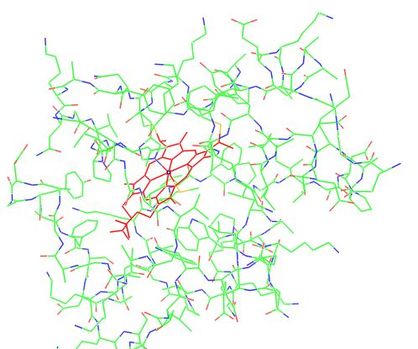

Show main structure as helices etc. BR/select molecules; Clk on any bit of main structure; TR/sele/Show/cartoon.

Show haem in a special way. BR/select/residues. Select HEC on sequence bar; TR/sele/Show/sticks. Colour/ red.

Show iron as red sphere: BR/Select/atom. Clk on position of iron; TR/sele/Show/sphere; Colour/red.

Show coordination of the iron: The iron in cytochrome c is coordinated to a methionine on one side and histidine on the opposite side.BR/Select residue; Clk on methionine (yellow) touching the iron. TR/sele/Show/sticks. Now Clk on histidine touching iron and do the same.

Hide lines: BR Select Molecules; Clk on main structure; TR/sele/Hide lines.
Figure 3. Before removal of lines. Showing cartoon helices etc; coordination of the iron with histidine (left) and methionine (right)
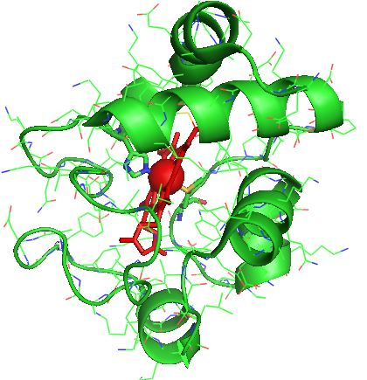

Playing with the structure
It is a good idea to explore your structure. First save it so you can go back if you get confused. Especially see the effect of showing as spheres, sticks, etc (using TR menu/Show). These can then be hidden (TR menu/Hide).

Using Slab to isolate parts of interest.
Rotate wheel to move into the molecule, removing structure. Here it is used to show the haem coordination
Figure 4 Slabbed to show haem coordination etc
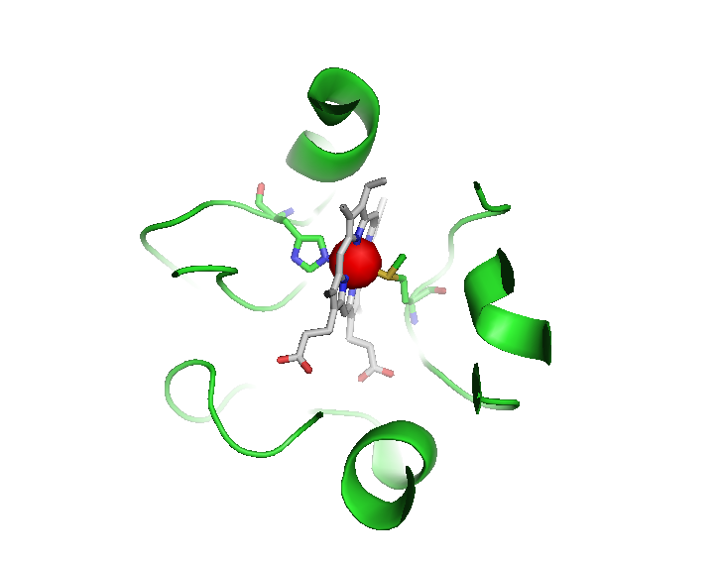

Example: Isolation of a single helix to play with.
Start with the cytochrome structure. Save with name helix.
BR/sele/residues; On sequence bar clk all residues from 1-84, leaving the C terminal helix unselected. TR/sele/Action/remove everything – removes all that you selected. To hide the haem: Select HEC; then TR/sele/Hide/everything.
Show main structure as helices etc. BR/select molecules; Clk on any bit of main structure; TR/sele/Show/cartoon.
Centre on the residue in middle of helix: BR/select Residues; Clk on centre of helix; TR/ sele/Action/centre.

Eg Show/sticks. This show sticks AND helix. Hide helix by keeping the selection and TR/Hide cartoon.
Show hydrogen bonds. BR/select molecules. Clk on structure; TR/sele/Action/find/polar contacts/just intra main chain. TR/sele-polar-conts/show as dashes. TR sele-polar-conts/Colour/red.
Figure 5 showing an isolate helix with hydrogen bonds between carbonyl oxygens and histidine nitrogen.

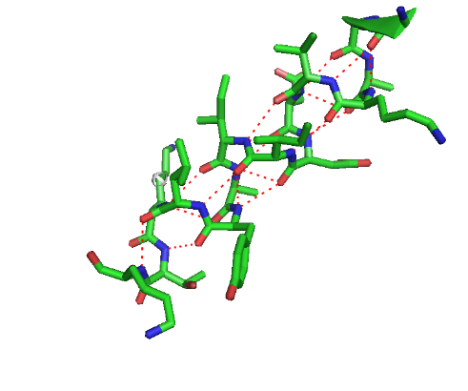
Stereo presentation
Top menu/Display.Stereo. Can choose as wall eyed or cross eyed. (Wall eyed is more correct). This gives 2 images side by side. To view you must reduce the size on the screen so that any 2 residues are 7cm apart.
Figure 6 Final picture of cytochrome c_{H} showing haem in the cleft bordered by the characteristic helices
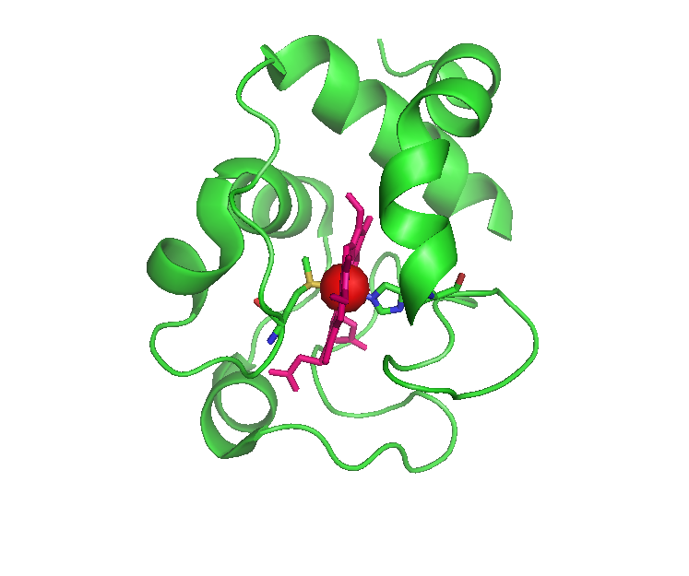

Figure 7 Stereo picture (Adjust size so that iron atoms are 7cm apart then stare into the distance; gradually you will see a central iron atom and then you will see it in 3 Dimensions)
